Report
The following report is a description of the findings of the analysis of the data related to climate change which was collected from the World Bank. We will hereby describe the contents of the report.
We will first describe the dataset which was collected from the World Bank climate change repository. The file consists of 20216 rows and 65 columns. The column names contain the following: Country Name, Country Code, Indicator Name, Indicator Code and 61 columns containing years 1960 to 2020. There are 266 country names and country codes for the corresponding countries. There are 76 indicator names in total for each country. The country names include countries such as Aruba, Malaysia, North America, Guyana, Zimbabwe, India, China, Oman, Honduras. Indicator names include Urban population, CO2 emissions, Agricultural land, arable land, renewable electricity output, electric power consumption.
In the next part, the various analysis results are described. We first started with the indicator name “Population, total”. Also we removed columns which are not needed: country code, indicator name, indicator code and the columns for the years 1960-1989. We are analysing data from 1990-2020. For each of the indicator names whose analysis is done, we take into account 7 countries: Malaysia, North America, Zimbabwe, India, Canada, China and Germany. Since the dataframe has the years as columns, the dataframe was transposed to change the years as rows and the country names as columns. After that the datarame.describe() function was used which returns the statistical results such as count, mean, standard deviation, min, max, 25%, 50% and 75%. These results are returned for each county. From the results we found that the highest mean value for total population is from China and the lowest from Zimbabwe. The standard deviation is lowest for Germany and highest for India. After that we calculated the correlation among all the countries and plotted the correlation matrix. It was found that Germany has the least correlation with all other countries It can also be seen over the years, both China and India has a gradual increase in the total population compared to the other countries.
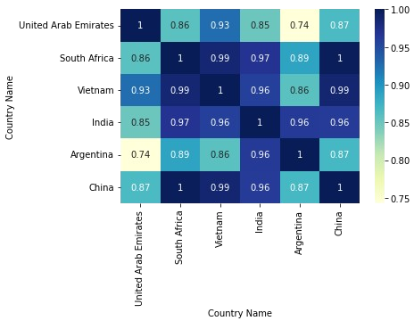

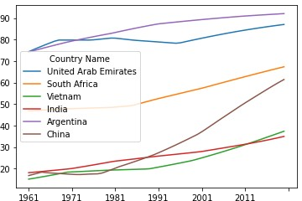

For the next indicator name “population growth”, the highest mean is for United Arab Emirates and the lowest is for China. The highest standard deviation is for United Arab Emirates and lowest for Argentina. The plot for the countries over all the years shows that the growth of population for United Arab Emirates changes very much unlike the other countries. From the correlation matrix it can be seen that all other countries has low correlation with United Arab Emirates.
For the indicator “CO2 emissions (kt)”, we find from the plot that China has the highest rate of emissions followed by India. Also it can be seen from 2001, there is a steep increase of CO2 emissions in China.
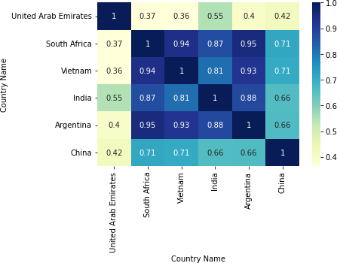

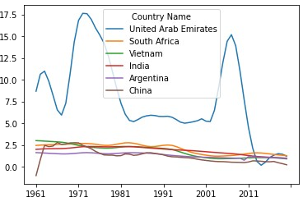

In the case of “Agricultural land”, the plot for all countries over the years whose that Vietnam has an increase in agricultural land with South Africa having the highest percentage of agricultural land followed by India. United Arab Emirates has the lowest percentage of agricultural land which is quite obvious as it is mostly dry land.
The plot for the indicator “electric power consumption” for all the countries over the years shows that United Arab Emirates has the highest consumption with China having an increase from 2001. India still has a low power consumption which maybe due to the fact that most of India’s population is from the rural areas and power consumption in rural areas is less compared to urban areas. However, from 2011 there is a gradual increase on the power consumption.
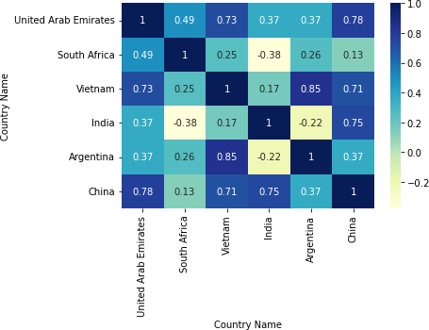

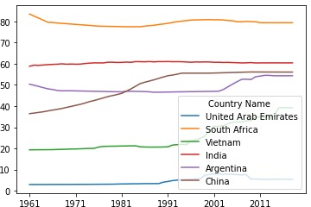

The next is the correlation between agricultural land and arable land for all countries. It can be seen that Vietnam has the highest correlation of agricultural land with arable land. Surprisingly, UAE has much higher correlation value compared to India.
The last correlation is between urban population and electric power consumption. It can be seen that India has the highest correlation value suggesting that the urban population is consuming more power. UAE has a surprisingly low value.

